

**Principal: Dr. Frost**

**Assistant Principal: MRs. Parker**

**Assistant Principal: Mr. Jenkins**

VPA Dance Program

Pre-VPA Syllabus

Artistic Director

Mr. Batista

2019-2020



**Syllabus for Encore VPA Dance Program at Booker Middle School**

**Adjunct Teacher 2018-19: Mr. Powell**

**Course Description**

VPA Dance at Booker Middle consists of various types of dance forms. There is a strong emphasis on ballet technique. This provides the groundwork for learning other dance styles such as modern and jazz, incorporating improvisation and choreography. We will also briefly touch on several other international dance forms (such as musical theatre, bollywood, ballroom, salsa, hip-hop, African and even dance aerobics, which incorporates strength, flexibility and conditioning) and how they impact our society today and through history. Students will gain an overview of dance vocabulary and composition, dance history, anatomy, and music appreciation throughout the course of this program. The goal is to produce students who will continue to love dance as audience members, choreographers, dance critics, dance therapists, dance teachers, as well as professional dancers.

# *Ballet*

[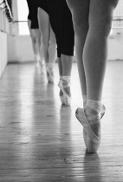](http://www.betterphoto.com/gallery/dynoGallDetail.asp?photoID=1081743&catID=1183&contestCatID=&rowNumber=17&camID=) This class is based on classical technique under **the ABT National Training Curriculum.** This class will focus on correct alignment, ease with movement, and moving to the fullest potential with anatomical knowledge and awareness to prevent injuries. The dancer uses ballet skills and techniques that can be applied to other dance techniques in a practical way. The class will have barre exercises to improve alignment, increase awareness, stretch and strengthen and then, followed by more complicated combinations in center to show balance and coordination.

***Modern***

This class focuses on correct alignment, moving freely through the space, and exploring new ways of moving. The class begins with floor exercises leading into standing exercises. Following with sequences across the floor and moving through the space. The class ends with a final combination incorporated with improvisation, which is seen throughout the class.

***Jazz***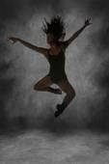 **(Hip-Hop)**

This energetic and exciting class has a technical focus on alignment, strength, and phrasing. The class starts with a warm-up with emphasis on abdominal and upper body strength as well as flexibility and control of the entire body. Following with an adagio for balance and stability, then more complicated combinations across the floor and in center. These combinations in different jazz (Hip-Hop) styles (influenced by classical jazz, Latin, modern, and musical theatre styles) improve and emphasize diversity in movement qualities and dynamics.

**Classroom Expectations**

1. Respect yourself, your classmates, your teacher, and your space.
2. Use positive words for yourself and others.
3. You must be properly dressed out for class, without jewelry.

NO JEWELRY (Including rings, bracelets, anklets, and silly bands)

1. Keep track of all personal belongings (YOU are in charge of your own personal belongings)

(Ex. write your names in your shoes & clothing with black permanent marker)

1. Food, drinks, gum, street shoes and negative attitudes should **NOT** be brought into the classroom. (Bottled water is allowed, **NO** Eating in the Dressing rooms)
2. Be in control of your **voice, mind, body**, and **space** at all times.

# *Voice, Mind, Body, Space*

***Voice****- Express yourself through your movements, not your voices.*

***Mind****- Stay focused and concentrated, be on task.*

***Body****- Keep your hands and feet to yourself*

***Space*** *- Stay in your “personal dance space” and in your own area.*

1. Due to the nature of the class, physical corrections will be made by vocal corrections, demonstrations and **TOUCH.**  These will be appropriate for the correction. If you have any issues on being corrected by physical ***TOUCH***, please inform me of this immediately (in private if need be).

# Dance Class Etiquette

* No Chatter During Class
* Arrive to class on time (Being Tardy or Absent from Rehearsal)
* No Cliques
* Be fully prepared for the appropriate class (No Inappropriate Attire)
* Have Proper Spacing in Class
* Respect your teacher and the lesson you are being taught
* Respect your fellow dancers/students and the work they are doing
* Participate in the class to the fullest of your ability
* Show Appreciation to the art form of Dance

[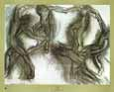](http://affiliates.allposters.com/link/redirect.asp?item=125069&AID=42624438&PSTID=2&LTID=1&TID1=4&lang=1)

**Quiet Signals**

1. If you hear me talking, you are quiet.
2. I’ll Say, Clap once if you can hear me…etc
3. If you see my hand go up, you are quiet.
4. If you hear me clap, you repeat, and you are quiet.
5. If someone else is talking, you are quiet.

**Entering Procedures**

*Come into the classroom* ***QUIETLY****, and take off your shoes*

1. Place all belongings in your lockers including, your book bags, jewelry, cell phones and personal belongings.
2. Check the Activboard for bell-work if there is any assignments; take out your folders/binders to write in; **if not**, go get changed and get ready to dance.
3. Dress out and change in the dressing rooms (Take with you **only** your dance clothes to change, leave your book bags and shoes in the classroom area and in your lockers)
4. When you are dressed, come onto the dance floor to **your assigned barre area** (or sit in a circle) and wait **quietly** for the rest of the class and **warm-up and stretch** on your own.

**Begin Class/Attendance Procedures**

1. Sit in your assigned barre area or rows. I will inform you or put on the activboard which row is in front. After you are in the front, the following week, you move to the back, and we rotate this way or when asked to rotate by the teacher.

**Ex. of Attendance Procedure**

1. When I say “Butterfly”, you get into that position. We begin our roll call routine.
2. Breathe in and out 4 times.
3. Stretch to the right, then to the left, holding for 4 counts each.
4. Both arms come up to high 5th, touch the floor behind you, as you look at the sky.
5. Slowly roll down over your legs.
6. When I call your name, you roll up through your spine, look at me, and roll back down slowly and continue stretching.

**Exiting Procedures**

1. Follow the teacher for Réverénce (showing respect, appreciation, and thanks to you teacher and classmates or audience).
2. Clap and personally thank your teacher.
3. Make sure the room is clean and any materials you used are put away.
4. Gather all of your belongings and get changed back in the dressing rooms or rest rooms

**Classroom Transitions**

**Ex. of Classroom Transitions**

1. Wait until your row number is called to get or put back any materials.
2. Raise your hand for any questions.
3. If you finish any written work early, **always warm-up and stretch**.

**Campus Transitions/Evacuation procedures**

1. Put only your shoes on. Make sure they are completely on (the backs, tied laces, etc.)
2. Leave all other belongings in the classroom (you may take a purse or wallet if you have one)
3. Line up in a single file line **quietly** on the street shoes area.
4. Listen for further directions.

**Restroom/Water Breaks**

There is plenty of time to use the restroom when you are changing out. Please do so then, instead of interrupting class time. IF YOU NEED TO USE THE RESTROOM FOR **EMERGENCIES ONLY**, YOU NEED TO ASK BEFORE YOU GO. Please keep a bottle of water nearby.

**Materials Borrowed From Me**

**(Exampler)**

If you need to borrow a pencil or something, you must sign it out and give me something else on layaway.

**Assignment Headings**

**(Example)**

First and Last Name

Date

Assignment

**Bell-work**

Be sure to check the board when you come in to see if there is an assignment that you need to be working on or materials you need to get. All bell-work is to be kept in your notebook. Your notebook can be kept in the class in the wooden shelf or wall cont (or in a bin that we can assign to your class).

**Homework and Make-up Work**

**(Example)**

Place all Homework and Make-up Work in the assigned container.

(If any work is assigned)

**Observations**

When you have a valid excuse for not being able to physically dance, you must write an observation. You may be given questions or topics to write about. This must be dated and turned in at the end of class. You will still receive deductions on your participation grade, but you will learn the concepts needed for any movement learned from class.

**SPECIAL NOTE REGARDING CELL PHONES…**

CELL PHONES ARE TO BE SILENCED AND AWAY. In keeping with Booker Middle School campus policy, any phones that ring, are used, consulted, or seen during class or in the dressing rooms will be confiscated and delivered to the main office where a parent or guardian must pick them up.

(If I see any cell phones out in the dressing rooms, THEY WILL BE MINE!!!)

**Possible Daily Schedule for Pre-VPA Students**

**Mon, Wednesday and Thurs** – *Ballet Technique* under **the ABT National Training Curriculum** and Floor-Barre under the **Zena Rommett Floor-Barre™**

*– This may vary depending on how hard you are working throughout the week.*

Wear black leotard, pink or skin colored tights, ballet shoes, hair in bun or high ponytail, ballet skirt is permitted, **no jewelry.** (Boys wear black dance pants or shorts and black or white t-shirt, with black ballet shoes or bare feet, no socks. Unless specified)

**Tuesday and Friday**- *Modern/****Horton****/Contemporary/ Jazz/ Choreography/ Composition* (We may do dance history, or another form of dance related to the unit we are doing at the time)

You may put your black pants over your leotard and tights. You may be barefoot or wear jazz shoes occasionally if preferred. (Boys wear black pants or shorts and may be barefoot or wear black jazz or ballet shoes occasionally if preferred.)

**NO JEWELRY,** **NO GUM WHATSOEVER**. Your hair must be up and out of your face.

**Advance Intermediate Beginnings**

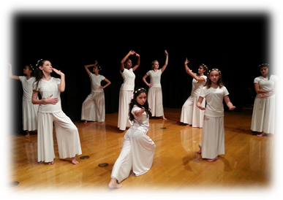

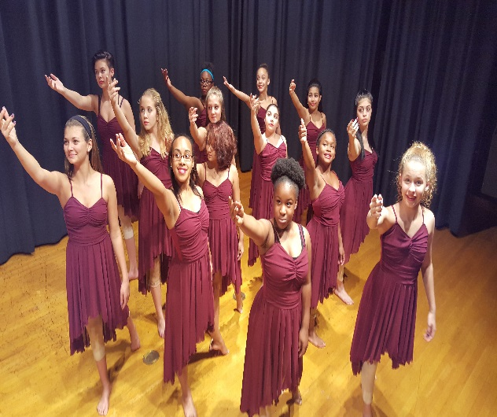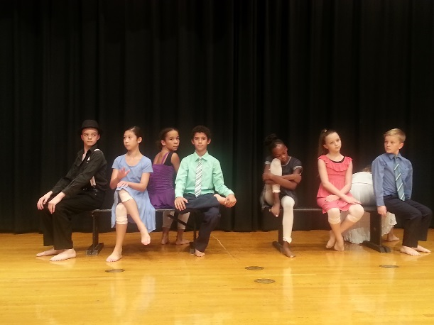

**Grading System**

1. Dancers are graded on Participation Daily. Dancers are excused from participating from class **ONLY with a written excuse from a doctor**. A parent note can only modify the physical movement the student does; **it does not** excuse them from dressing out. *Dancer’s grade is affected by each unapproved non-participation.* *This includes Proper Dance Attire*. If a student does not have appropriate dance attire, it hinders their movement ability, and is unable to fully execute the skills and concepts. (If the student does not dress out in the proper dance attire they **will** participate, but will loose participation points for the day, since they cannot be assessed on the skills they learned correctly.)
2. Dancers must have Attendance, that’s why it’s called *attend dance,* because you need to be here in order to learn. Students will be deducted 5 points from their attendance grade for every UNEXCUSED ABSENCE, because they have not been in class to learn important information and skills that usually cannot be made up. (Only documented excused absences will be taken into consideration. Please make sure that I see those excused absent documents so you will not be deducted any points for absentees.) If a student is absent, it is their job to find out what they missed and if there is anything they can make up. I will not seek your student out for make-up work. They MUST ask me!
3. Each dancer will keep a 3-hole folder with pockets and notebook paper or a journal, for taking notes and storing handouts. They are allowed to take this home to study.
4. In addition to these sections, there are quizzes, tests, projects, group work, and papers. There is usually 1-2 of each per grading period.
5. Students are also graded on their rehearsals and performances.

**Consequences for Inappropriate Behavior**

1. After the first infraction, the student will receive a warning. **This is your Warning!!!! DON’T DO IT PERIOD!**
2. After the 2nd infraction, the parent will be contacted by the teacher via phone, or email/letter of concerns after the dancer has **refocused, along with a written SIRS!**
3. After the 3rd infraction, a referral will be written **along with a written SIRS** and the dancer will have an administrator oversee the consequences for the infraction. (This results in the removal of a dance piece or two.)
4. After the 4th infraction, there will be another written referral **along with a written sir** and the student will again be addressed by an administration. . (This results in the removal of the VPA Dance Concerts.)
5. After **5** infractions of the guidelines, if a student does not comply with my expectations of behavior ***IN & OUT*** of my class, (including ISR, OSS or other written SIRS or Referrals by other teachers), they will not be a part of the Dance Program. I will only have students that show me why they deserve to be a part of this program based on their attitude and their actions.

**Incentives/ Rewards**

Performing is a **privilege**. You might be invited to perform if you are doing the very best you can and putting forth 100% effort. You may even be asked to do a solo, duet, trio, or quartet. The students who I think can handle the extra pressure and show how much they want to be here, will be the ones who will get the extra chances. At times, I may even ask a small group only to represent our program at a special event. These are the most dedicated and deserving students who will get these opportunities.

Field Trips are also considered privileges. Students who complete all assignments, get information back on time, and pay their field trips fees, will be allowed to go.

***Master classes are another major reward. Only students who are dressed out appropriately and on the best behavior will be allowed to participate in master classes and even guest artist choreography.***

**My Contact Information**

I like to stay in very close contact with parents through email. So, please include your email address at the bottom of this page. Please get in touch with me if you have any questions, concerns, thoughts, ideas, or just want to hear how your dancer is progressing in class.

Please email me at [Pedro_Batista@sarasota.k12.fl.us](mailto:Pedro_Batista@sarasota.k12.fl.us)

Or call me at Booker Middle at 941-359-5824 ext. 60951

Please remove, sign and date stating that you have read the entire packet and commit to being a part of this program. Please provide your phone number and email, so that I can relay important information.

------------------------------------------------------------------------------------------------------------

Student ______________________________________ Date____________

Parent________________________________________ Date____________

Phone Number_______________ **Email**_________________________